INTEGRACJA ZESPOŁÓW KLASOWYCH
wycieczka klasy II b

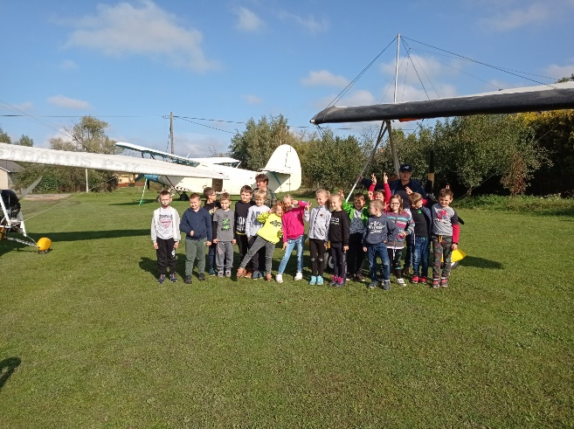
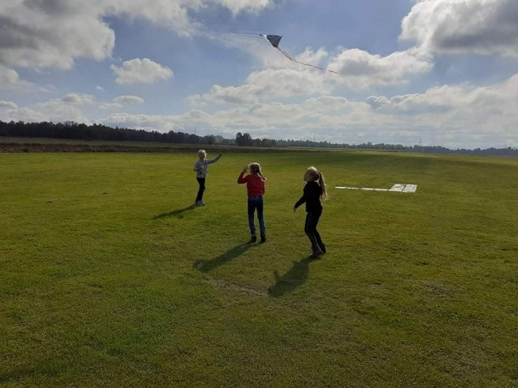

https://spborowa.edupage.org/news/?eqa=d2lkPW5ld3NfTmV3c18xX3AmbmV3c2FyY2hpdmVmPTIwMjEtMTAmb2Zmc2V0X25ld3NfTmV3c18xX3A9MjA%3D#photos:album:1553

Dbanie o kondycję i aktywność fizyczną
ZŁOTO I SREBRO W FINALE POWIATOWYM W SZTAFETACH

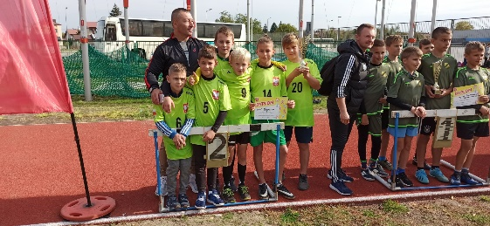

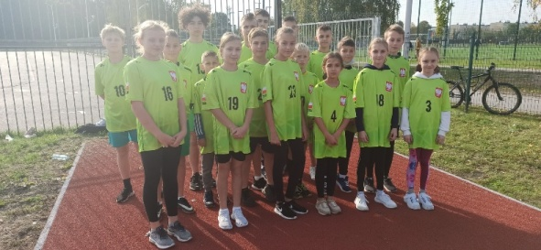

https://spborowa.edupage.org/news/?eqa=d2lkPW5ld3NfTmV3c18xX3AmbmV3c2FyY2hpdmVmPTIwMjEtMTAmb2Zmc2V0X25ld3NfTmV3c18xX3A9MjA%3D#photos:album:1554
Dbanie o harmonię psychiczną uczniów
7-DNIOWY WYJAZD UCZNIÓW DO
KAWĘCZYNKA NA ROZTOCZU

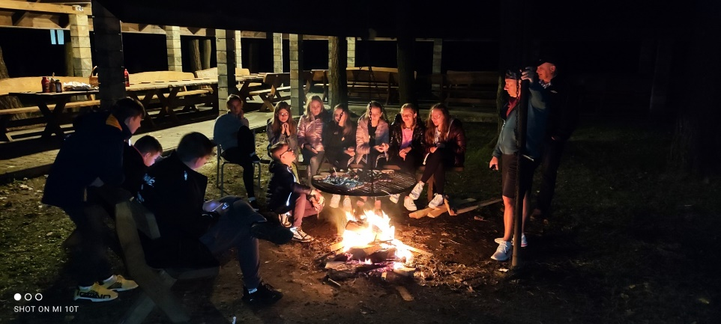
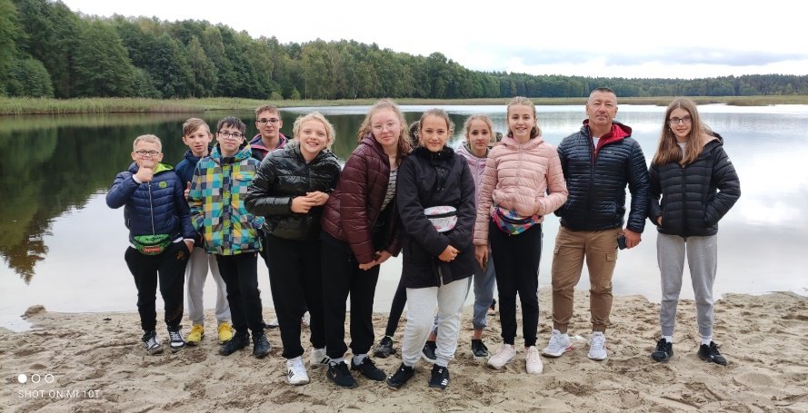

https://spborowa.edupage.org/news/?eqa=d2lkPW5ld3NfTmV3c18xX3AmbmV3c2FyY2hpdmVmPTIwMjEtMTAmb2Zmc2V0X25ld3NfTmV3c18xX3A9MA%3D%3D#photos:album:1555
Kształtowanie postawy szacunku do historii
KLASY III NA WYCIECZCE
W OSADZIE NEOLITYCZNEJ

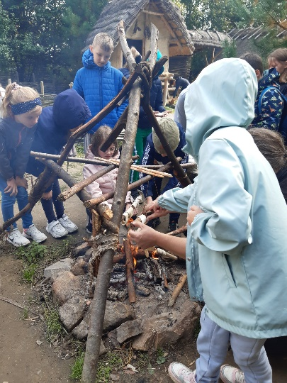
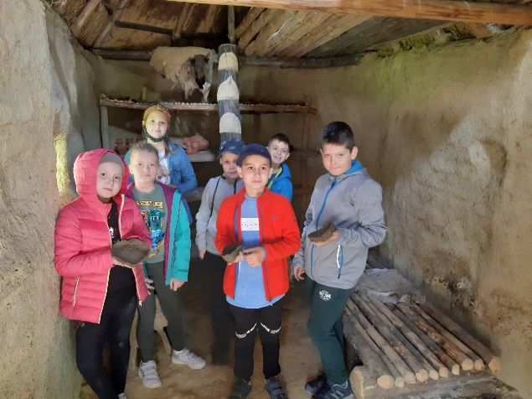

https://spborowa.edupage.org/news/?eqa=d2lkPW5ld3NfTmV3c18xX3AmbmV3c2FyY2hpdmVmPTIwMjEtMTAmb2Zmc2V0X25ld3NfTmV3c18xX3A9MA%3D%3D#photos:album:1556
Rozwój duchowy
ROZUMIEM, SZANUJĘ, AKCEPTUJĘ

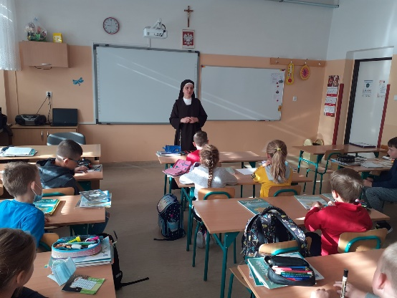
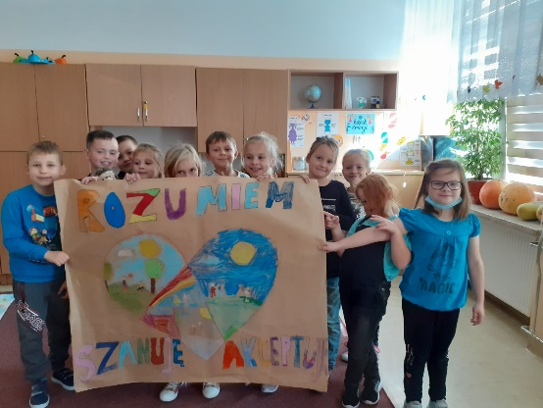

https://spborowa.edupage.org/news/?eqa=d2lkPW5ld3NfTmV3c18xX3AmbmV3c2FyY2hpdmVmPTIwMjEtMTAmb2Zmc2V0X25ld3NfTmV3c18xX3A9MA%3D%3D#photos:album:1563
Rozwijanie mocnych stron ucznia
OKAZALI SERCE I POMOC!!!

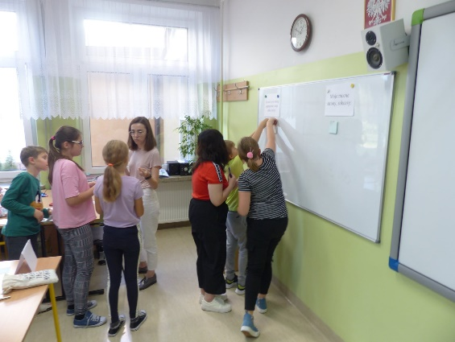
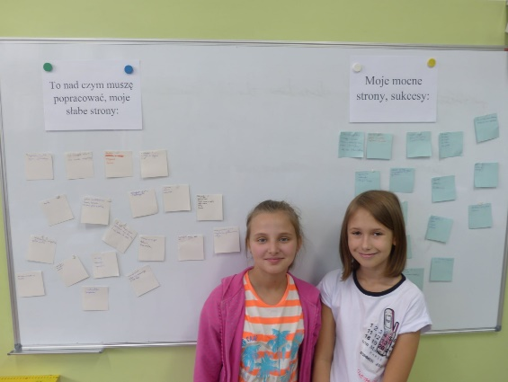

https://cloud7b.edupage.org/cloud?z%3A%2FWr1JDEM5feBmDH0IL%2FMCIMQGSNldEeKXzOG8%2BijETmEEvYjP5VFlZawyLBYXYni
Budowanie pozytywnych relacji rówieśniczych
OGNISKO INTEGRACYJNE KLASY VII B

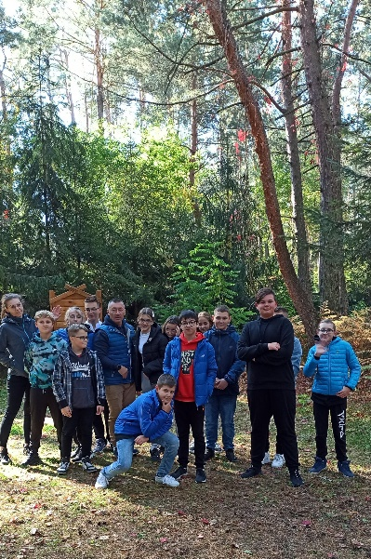
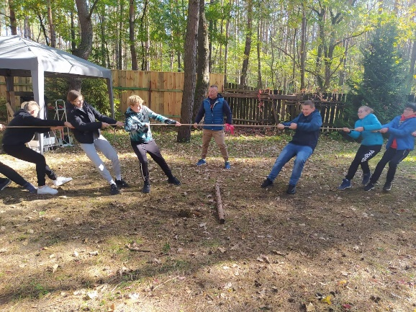

https://spborowa.edupage.org/news/?eqa=d2lkPW5ld3NfTmV3c18xX3AmbmV3c2FyY2hpdmVmPTIwMjEtMTAmb2Zmc2V0X25ld3NfTmV3c18xX3A9MA%3D%3D#photos:album:1558
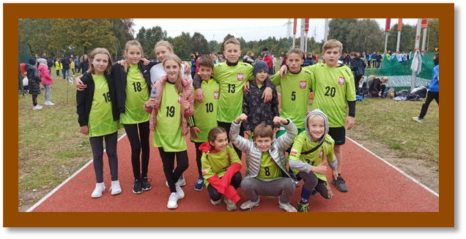
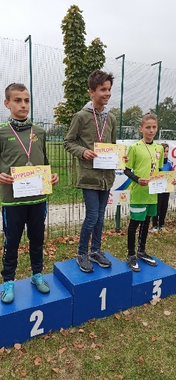
https://spborowa.edupage.org/news/?eqa=d2lkPW5ld3NfTmV3c18xX3AmbmV3c2FyY2hpdmVmPTIwMjEtMTAmb2Zmc2V0X25ld3NfTmV3c18xX3A9MA%3D%3D#photos:album:1560
Pozytywna rywalizacja
MEDALE W FINALE POWIATOWYM W BIEGACH PRZEŁAJOWYCH

Budowanie właściwego stosunku do świata
ZAJĘCIA W TERENIE KLASY II A

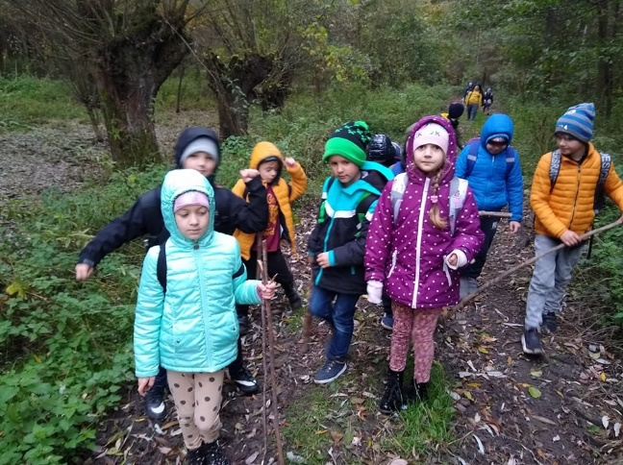
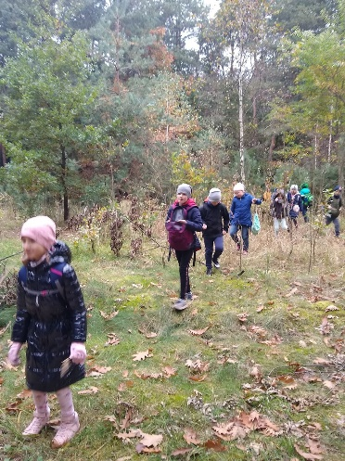
https://spborowa.edupage.org/news/?eqa=d2lkPW5ld3NfTmV3c18xX3AmbmV3c2FyY2hpdmVmPTIwMjEtMTAmb2Zmc2V0X25ld3NfTmV3c18xX3A9MA%3D%3D#photos:album:1561
Uwrażliwianie na dziedzictwo historyczne
WYCIECZKA KLAS SZÓSTYCH DO SKANSENU W KOLBUSZOWEJ

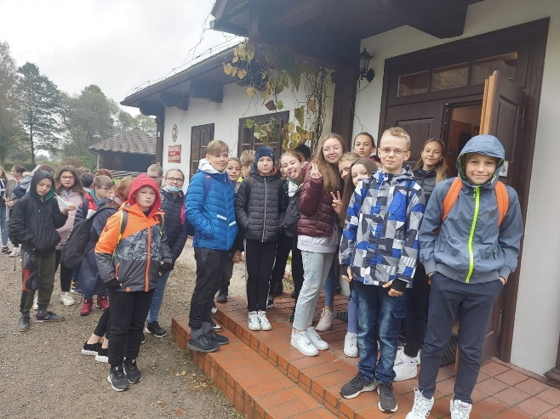
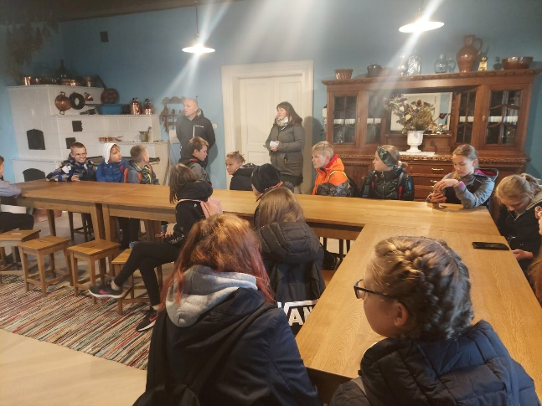

https://spborowa.edupage.org/news/?eqa=d2lkPW5ld3NfTmV3c18xX3AmbmV3c2FyY2hpdmVmPTIwMjEtMTAmb2Zmc2V0X25ld3NfTmV3c18xX3A9MA%3D%3D#photos:album:1566

Dbanie o postawę prozdrowotną
ŚWIATOWY DZIEŃ MYCIA RĄK
W ODDZIAŁACH PRZEDSZKOLNYCH

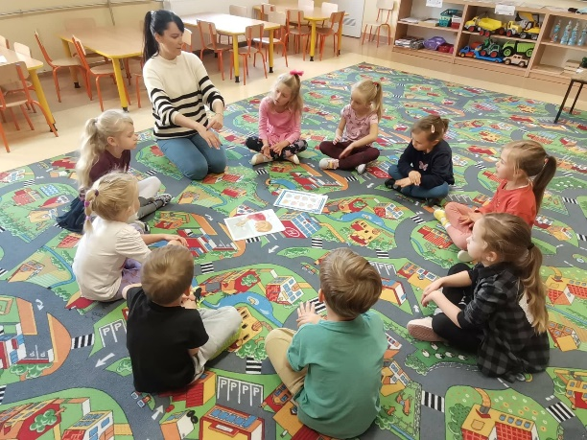
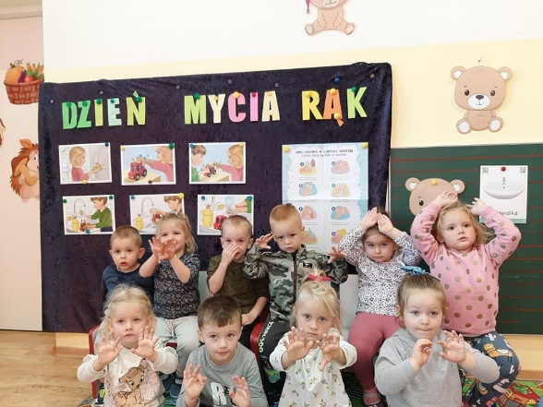

https://spborowa.edupage.org/news/?eqa=d2lkPW5ld3NfTmV3c18xX3AmbmV3c2FyY2hpdmVmPTIwMjEtMTAmb2Zmc2V0X25ld3NfTmV3c18xX3A9MA%3D%3D#photos:album:1568
Rozwijanie pasji i zainteresowań
WYCIECZKA KLASY II A
DO ZALIPIA

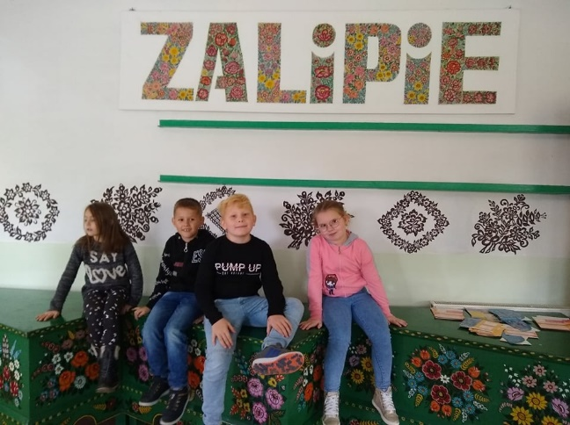
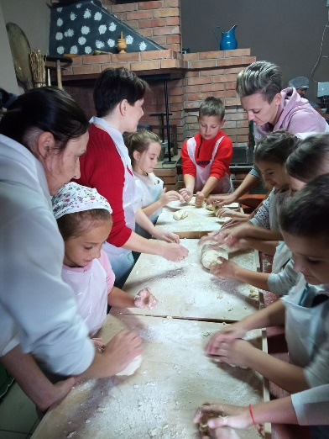
https://spborowa.edupage.org/news/?eqa=d2lkPW5ld3NfTmV3c18xX3AmbmV3c2FyY2hpdmVmPTIwMjEtMTAmb2Zmc2V0X25ld3NfTmV3c18xX3A9MA%3D%3D#photos:album:1567
Rozwijanie aktywności fizycznej
WOJEWÓDZKI FINAŁ W BIEGACH PRZEŁAJOWYCH - KOLBUSZOWA

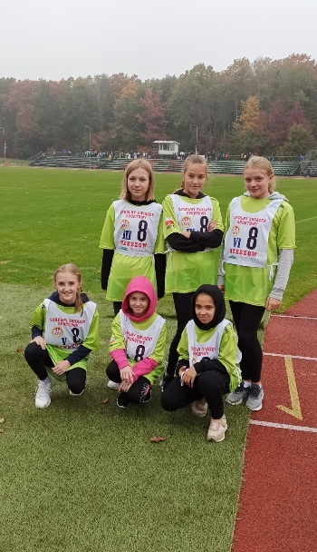
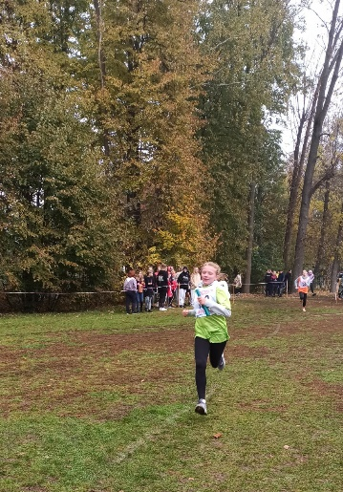
https://spborowa.edupage.org/news/?eqa=d2lkPW5ld3NfTmV3c18xX3AmbmV3c2FyY2hpdmVmPTIwMjEtMTAmb2Zmc2V0X25ld3NfTmV3c18xX3A9MA%3D%3D#photos:album:1570
Dbanie o bezpieczeństwo
PANI POLICJANT
W PRZEDSZKOLU

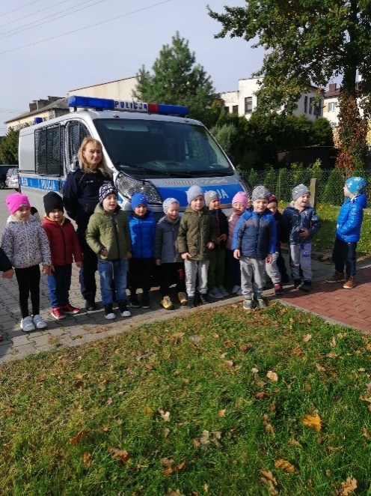
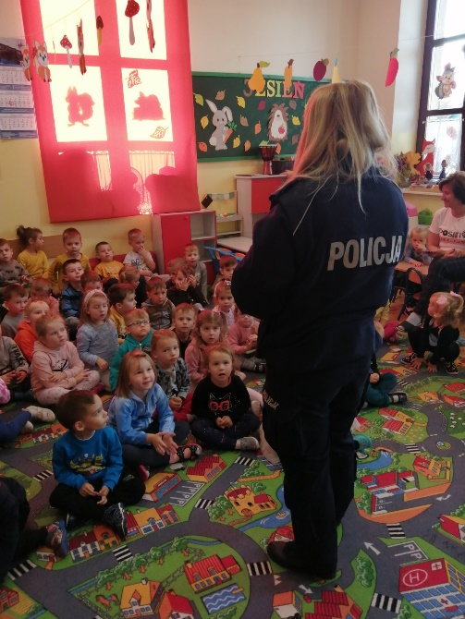

https://cloud1b.edupage.org/cloud?z%3A33DgdQXHulVTMfMKzSYDZrA74C9bqYMwRgEw2%2BkbVtz0ug9DgRUxNjAcX6BqnLEC
Właściwy stosunek do świata
ŚWIĘTO JESIENI W PZEDSZKOLU

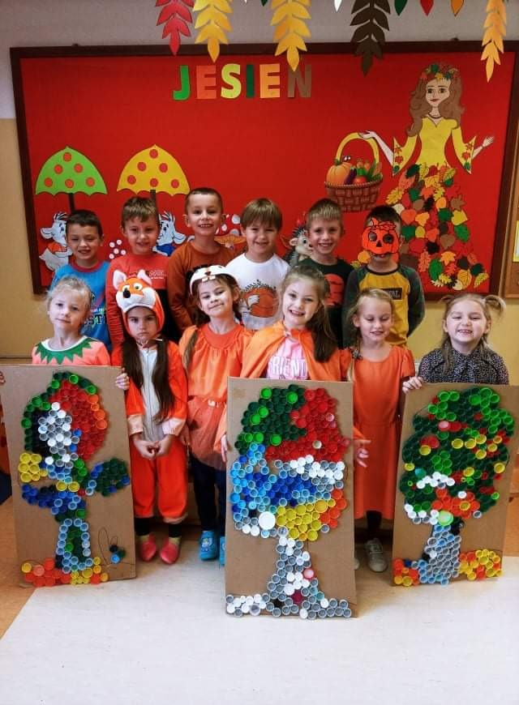
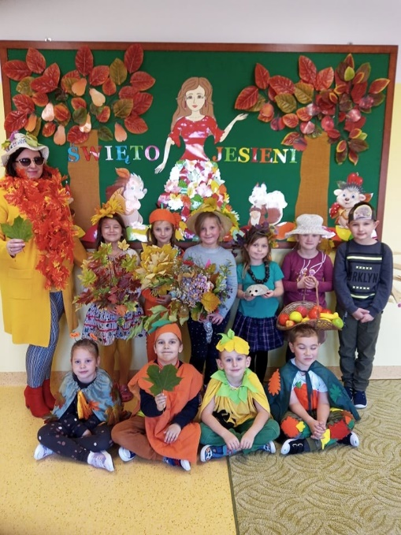

https://spborowa.edupage.org/news/?eqa=d2lkPW5ld3NfTmV3c18xX3AmbmV3c2FyY2hpdmVmPTIwMjEtMTAmb2Zmc2V0X25ld3NfTmV3c18xX3A9MA%3D%3D#photos:album:1573
Promowanie postaw ekologicznych
WYCIECZKA KLAS TRZECICH DO REZERWATU PRZYRODY „ZAMCZYSKO TURSKIE”

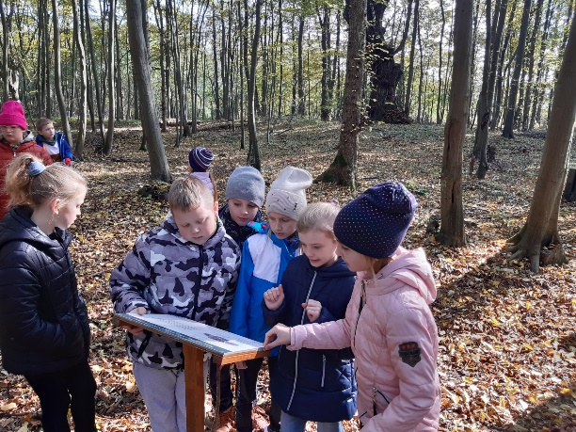
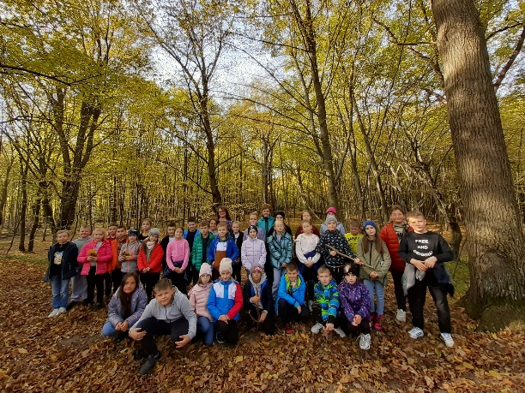
https://spborowa.edupage.org/news/?eqa=d2lkPW5ld3NfTmV3c18xX3AmbmV3c2FyY2hpdmVmPTIwMjEtMTAmb2Zmc2V0X25ld3NfTmV3c18xX3A9MA%3D%3D#photos:album:1571

Dbanie o ruch i aktywność fizyczną
WYCIECZKA KLAS PIĄTYCH DO WIELICZKI

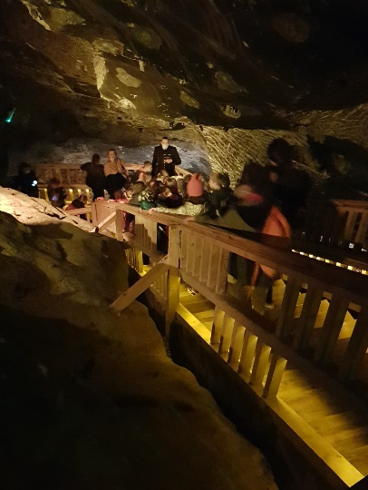
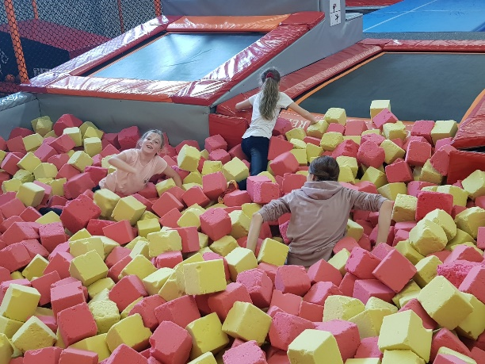

https://spborowa.edupage.org/news/?eqa=d2lkPW5ld3NfTmV3c18xX3AmbmV3c2FyY2hpdmVmPTIwMjEtMTAmb2Zmc2V0X25ld3NfTmV3c18xX3A9MA%3D%3D#photos:album:1578
Rozwijanie umiejętności życiowych
PRZEDSZKOLAKI ODWIEDZAJĄ POCZTĘ

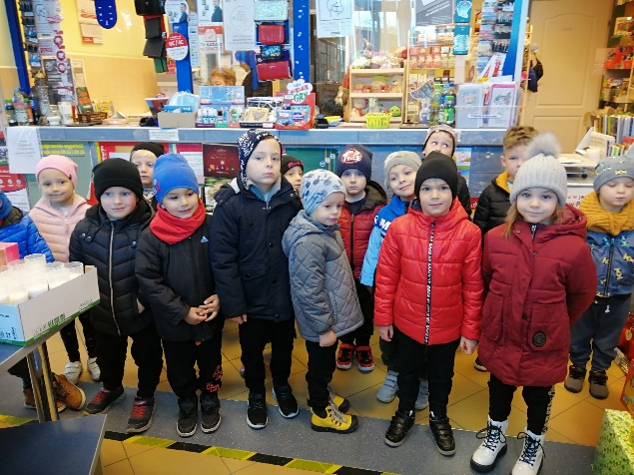
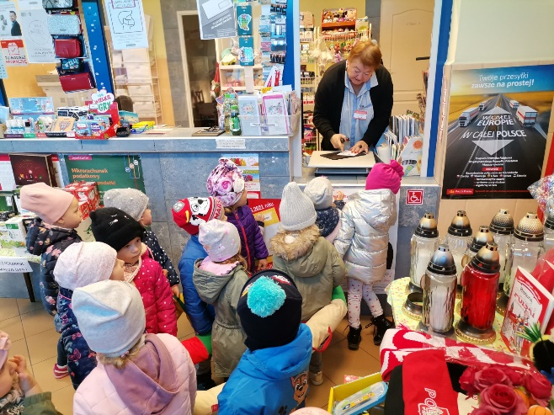

https://spborowa.edupage.org/news/?eqa=d2lkPW5ld3NfTmV3c18xX3AmbmV3c2FyY2hpdmVmPTIwMjEtMTAmb2Zmc2V0X25ld3NfTmV3c18xX3A9MA%3D%3D#photos:album:1579

